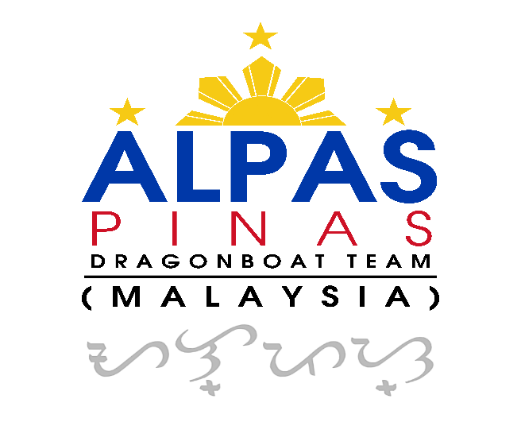
Alpas Pinas Dragonboat Team Debut in Malaysia

Established on 2 February 2024, Alpas Pinas Dragonboat Team Malaysia was created to unite Filipinos in Malaysia through sports, teamwork, and community spirit, while welcoming anyone who shares the same passion and values. Proudly led by Filipino expatriates, the team fosters a culture where Filipino spirit, camaraderie, and shared effort come first.
The team made its first international racing debut at “Isang Bangkang Malaya” in Singapore in June 2025, finishing a commendable 4th place. This inaugural race fueled their determination and set the stage for establishing a strong presence in Malaysia.
Building on that momentum, Alpas Pinas Dragonboat Team Malaysia made an impressive maiden Malaysian debut on 24 January 2026 at the Penang Mini Dragonboat Race. With 27 paddlers competing across the Open, Mixed, Women, and Masters categories, the team delivered a standout performance: all categories advanced to the Semi-Finals, while the Open Team proudly claimed a Bronze Medal, marking a significant milestone in the team’s journey.
Racing conditions were tough, with hot weather and choppy open-sea waters challenging all crews. Several boats either capsized or drifted off course, but Alpas Pinas Dragonboat Team Malaysia navigated the conditions safely, showcasing teamwork, discipline, and strong boat control.
The day began early at 6:30am with warm-ups and team briefings and ended with a celebratory dinner sponsored by Alfa Soundscape & Design, a moment of well-earned camaraderie. Paddlers proudly wore team jerseys sponsored by Smile Up Dental, while friends and supporters from the Philippines, Singapore, and across Malaysia cheered enthusiastically.
Looking ahead, Alpas Pinas Dragonboat Team Malaysia invites Filipinos in Malaysia—and anyone who shares a love for sports, teamwork, and community—to join the team. Together, we continue to grow as an inclusive, supportive community where unity, discipline, and shared purpose drive every paddle stroke.
“Alpas Pinas, get get AWWW!” — together, we paddle forward as one.

